**1. Write a Java program to**

**a. Perform Binary search operation**

**package** com.binarySearch;

**import** java.util.Arrays;

**import** java.util.Scanner;

**public** **class** BinarySearch {

**public** **static** **int** binarySearch(**int**[] arr, **int** key) {

**int** left = 0, right = arr.length - 1, mid;

**while**(left <= right) {

mid = (left + right) / 2;

**if**(key == arr[mid])

**return** mid;

**if**(key < arr[mid])

right = mid - 1;

**else**

left = mid + 1;

}

**return** -1;

}

**public** **static** **void** main(String[] args) {

Scanner sc = **new** Scanner(System.***in***);

**int**[] arr = {88, 33, 66, 99, 44, 77, 22, 55, 11};

Arrays.*sort*(arr);

System.***out***.print("Enter key to search: ");

**int** key = sc.nextInt();

**int** index = *binarySearch*(arr, key);

**if**(index != -1)

System.***out***.println("Key found at index: " + index);

**else**

System.***out***.println("Key not found.");

}

}

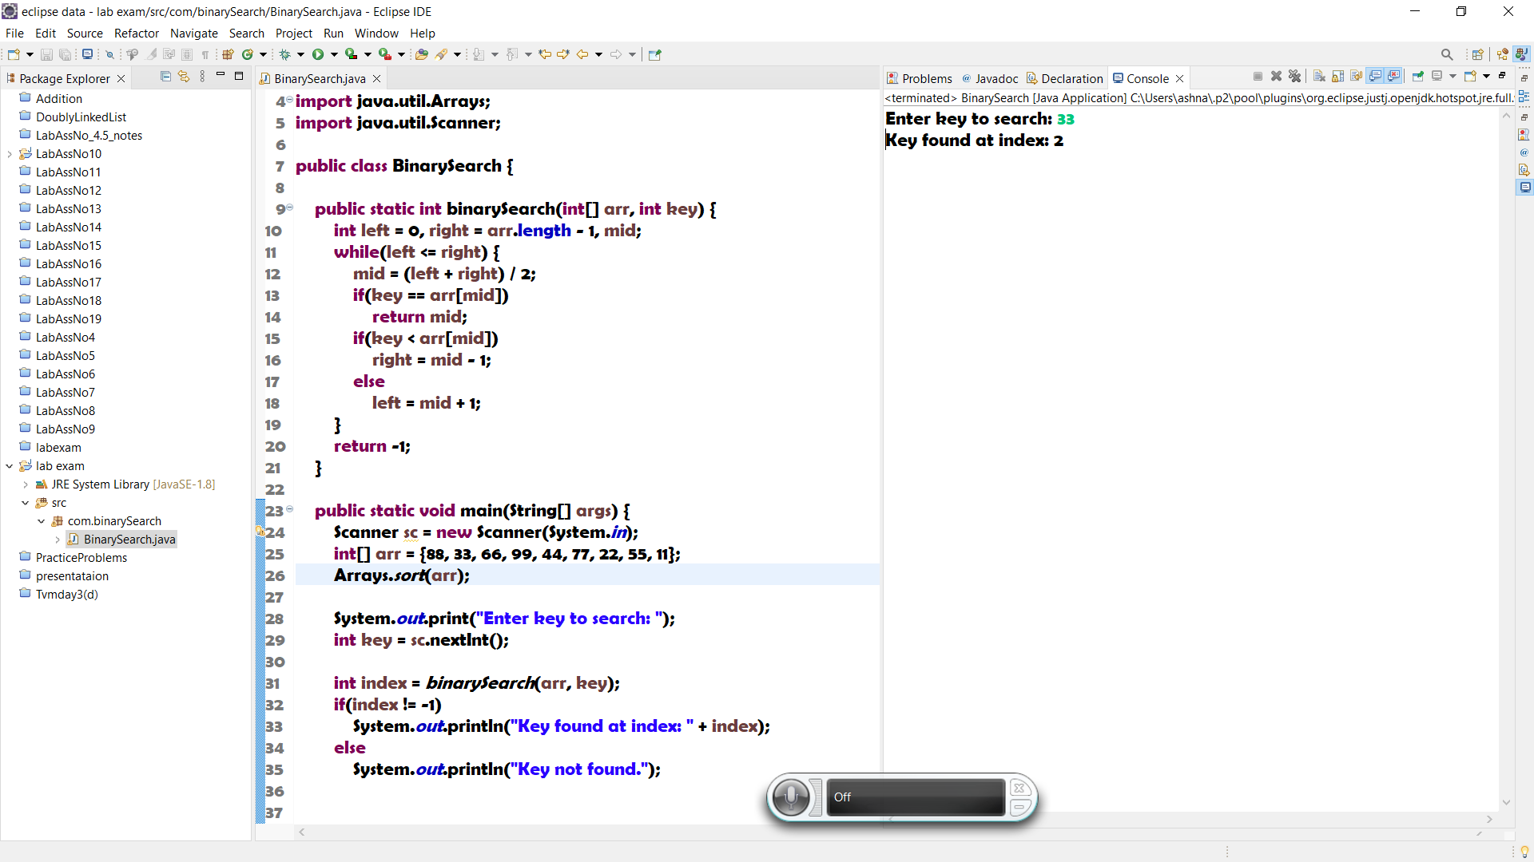

b. Implement stack using array concepts

**package** com.binarySearch;

**import** java.util.Scanner;

**public** **class** Stack {

**private** **int**[] arr;

**private** **int** top;

**public** Stack(**int** size) {

arr = **new** **int**[size];

top = -1;

}

**public** **void** push(**int** val) {

**if**(isFull())

**throw** **new** RuntimeException("Stack is Full.");

top++;

arr[top] = val;

}

**public** **void** pop() {

**if**(isEmpty())

**throw** **new** RuntimeException("Stack is Empty.");

top--;

}

**public** **int** peek() {

**if**(isEmpty())

**throw** **new** RuntimeException("Stack is Empty.");

**return** arr[top];

}

**public** **boolean** isEmpty() {

**return** top == -1;

}

**public** **boolean** isFull() {

**return** top == arr.length-1;

}

**public** **static** **void** main(String[] args) {

Scanner sc = **new** Scanner(System.***in***);

Stack s = **new** Stack(6);

**int** choice, val;

**do** {

System.***out***.println("\n0. Exit 1. Push 2. Pop 3. Peek\nEnter choice: ");

choice = sc.nextInt();

**switch**(choice) {

**case** 1: // push

**try** {

System.***out***.print("Enter value to push: ");

val = sc.nextInt();

s.push(val);

} **catch** (Exception e) {

System.***out***.println(e.getMessage());

}

**break**;

**case** 2: // pop

**try** {

val = s.peek();

s.pop();

System.***out***.println("Popped: " + val);

} **catch** (Exception e) {

System.***out***.println(e.getMessage());

}

**break**;

**case** 3: // peek

**try** {

val = s.peek();

System.***out***.println("Peek: " + val);

} **catch** (Exception e) {

System.***out***.println(e.getMessage());

}

**break**;

}

}**while**(choice != 0);

sc.close();

}

}

